From the Art Department:
October Mystery Artist: Edvard Munch,
The Scream

The Super Sleuths for the month of October were Rylie Gordillo, Eli Beissenherz, Elizabeth Francis, Tabitha Lynn, and Shawn Iliff.
There were many students who participated in the investigation to find out who the Mystery Artist was. The students who succeeded and got the answer correct were... Lorelai Kuecker, Konner Akau, Shaylin Haley, Dakota Reynolds, Chadlee Stein, Peyton Trautman, Jared Bermudez, Michyla Turner, Addison Klamm, Anna Dempsey, Taylor Gard and Aleyna Michaels.

Reminders
11-9-17 Board Meeting 6:30 pm
11-15-17 Early Release Day 1:45 p.m.
11-15-17 CES Thanksgiving Manners Meal
11-17-17 1st Grade Field Trip
11-21-17 Grandparents Day 1:30-3:00 pm
11-22-17 Thanksgiving Break Begins
11-27-17 School Resumes
11-27-17 Girls’ Practice Begins and Parent/Coaches Meeting
11-28-17 Boys’ Practice Begins and Parent/Coaches Meeting
11-29-17 Early Release Day 1:45 p.m.
12-1-17 PTO Hat Day for $1
12-11 Christmas Concert 7 pm CES gym: 4-6 Music Classes; 5-6 Band Classes; Singing Orioles
12-12 Christmas Concert 7 pm CES Gym: PK-3 Music Classes

Art to Remember:
If you would like to place an order, you may do so by using the online portal at: Order.ArtToRemember.com until January 12, 2018. You will need to enter your Online Order Code, which is provided for you on your student’s packet. If you have any questions contact Aimee Bredehoeft.
Physicals Needed for 5th & 6th Grade Sports
This is a reminder that all students participating in 5th & 6th grade basketball and cheerleading need to have a sports physical on file before they will be allowed to participate in practice. The form is available at most medical offices and can be downloaded here:
http://www.mshsaa.org/resources/pdf/ PrePartPhyEval_3314v2.pdf. This is the same form used by junior and senior high athletes.
Basketball Start Date
Practice for the 5th & 6th grade basketball teams will begin after Thanksgiving break. The girls will begin on November 27 and the boys will start on November 28. There will be a parent meeting at 5:00 both nights for parents and athletes to attend. Parents should plan on attending one of the meetings. The purpose of the meetings is to acquaint parents with the schedule, rules and regulations, academic eligibility and parent/student/fan sportsmanship. All parents will need to sign a code of conduct for their child to play. Also required for practice and play is the sports physical. The physical must be completed before any student can practice or play. The form for the physical is available at most doctors’ offices and on our website. At the meeting, parents will also have the opportunity to sign up for PTO Concession Stand shifts.
Christmas Concerts Scheduled
The annual CES Christmas Concerts will be held on the following dates: For grades four through six including music classes, bands and Singing Orioles- December 11. For students in Preschool through the third grade-December 12. Both programs are free of charge and will be held in the CES gym beginning at 7:00 pm. Doors open at 6:30 pm.
First Friday Hat Day
The CES PTO is again sponsoring First Friday Hat Days. On the first Friday of each month, students and staff may wear their favorite hat at school for a $1 donation to the PTO.

American Education Week
American Education Week is November 13-17, 2017. The week presents all Americans with a wonderful opportunity to celebrate public education and honor individuals who are making a difference in ensuring that every child receives a quality education. This year’s theme is "Great Public Schools: A Basic Right and Our Responsibility," and will be reflected in special observances each day of the weeklong celebration. Students and staff will have special dress up days in observance of the weeklong celebration. The dress up days are as follows:
13th Monday-Oriole Strong Day
14th Tuesday- Dress in Colors (wear clothing/colors of future college)
15th Wednesday-Dress as your Future Profession Day
16th Thursday- Dress as your Favorite Teacher Day
17th Friday- Wear Orange and Black
Sixth Grade Trip Reminder
Parents of sixth graders intending to take the sixth grade trip to Washington, D.C. are reminded that the initial payment along with the Commitment and Permission form were due Friday, November 2. With such a small class of students, it is important to know how many people are planning on taking the trip. Please make checks out to the Sixth Grade DC Trip.
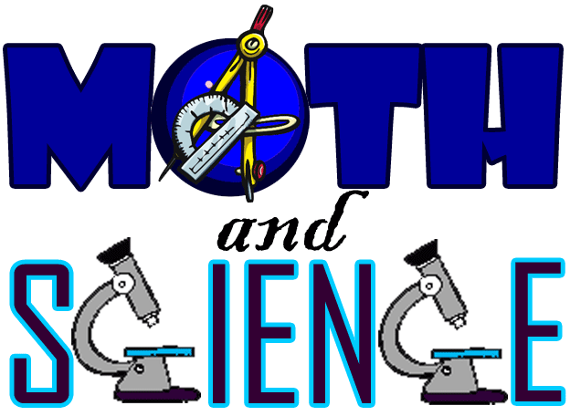
Science and Math Night is November 30th
On Thursday, November 30, CES will host a Science Night. This fun-filled night will begin at 6:30 pm and run concurrently with the 5th & 6th Grade Science Olympiad activities and Science Fair. At Science Night, students and their families will get the opportunity to try their hand at outrageous and fun science experiments. There will be science experiments for students in grades Kindergarten through sixth grade. Bring the whole family for science fun on CES Science Night!
PTO to Meet November 14 @ 7 pm
The next regular meeting of the CES Parent/Teacher Organization will be Tuesday, November 14 at 7:00 pm in the CES Library. All parents are encouraged to attend.
Progress Report Time
Progress reports will be sent home 11/17/17. As always if you have questions or concerns regarding your child’s progress, please reach out to your child’s classroom teacher.
Student Council Fundraiser
The Student Council is excited to offer you the opportunity to purchase an Oriole cup at the discounted price of $10. See order form attached.

Grandparent’s Day 2017
Grandparent’s Day at Concordia Elementary School will be held on Tuesday, November 21, 2017 from 1:30 until 3:00 pm. This is a wonderful opportunity for our students’ grandparents to see how their grandchildren learn at CES and a great way to start the Thanksgiving vacation.
Grandparent’s Day Arrival
Grandparents and other special guests may begin arriving at 1:30 pm. Parking is available in any of our parking lots, on Fourth Street and on Sunset Hills Drive. The entry doors on the West parking lot, East parking lot and front door will be open for easy access.
Grandparent’s Day Schedule
The event will run from 1:30 pm until 3:00 pm. There will be no assembly at the end of the day so our guests can enjoy the students in their classrooms.
Many of our special guests have multiple children to visit. Since there is no set schedule for activities, our guests should feel free to visit their grandchildren’s classrooms as they wish.
Guests are welcome to stay until 3:00 or leave earlier if they wish. In order to facilitate dismissal, we ask that all guests make their departure no later than 3:00 pm.
Attention Parents
If you would like for your child to leave at the end of the day with their grandparent, please indicate that in your student’s agenda. Be sure to sign and date.

Basketball/Cheer
Coaches: Marah Luetjen and Alexandria Williams
ALL practices and tryouts are closed to outside parties. All students wishing to tryout must have the following forms and information turned in before they can participate in practices:
• 3 Character Reference Forms (filled out by 3 separate teachers)
• Physical
• Signed permission form
**All students wishing to try out must ATTEND AND PARTICIPATE in 3 of 4 practices.
- Monday, November 6 - Thursday, November 9
Cheer Tryout Practices, 3:30-4:30 (elementary school gym)
- Friday, November 10th
Cheer Tryouts 3:30-5:00** (elementary school gym)
Thursday, November 16th
Uniform Fitting 3:30-4:30 (elementary school)
Official cheer practices will begin on Tuesday, November 28. These practices will be held from 3:30 - 5:00 on Tuesdays and Thursdays, and will be in the elementary school cafeteria. An official schedule with games and practices will be sent home closer to the start of practices.

SINGING ORIOLES
After a short break for Halloween, Singing Orioles will resume on Tuesday, November 7. Thank you to all of you who have been conscientious of the schedule and rehearsal times. Singing Orioles has had excellent attendance, and dismissal has run smoothly and on time.
The first performance for Singing Orioles will be at the Chamber of Commerce Chili/Soup Dinner on Saturday, December 2 at 6:00 p.m. This event will be held at the Community Building in Concordia. Singing Orioles should wear casual dress clothes for this performance. Admission is free.

Counselors Corner:
The character word of the month is Kindness. Kindness means being friendly, generous, and considerate to others. It also means accepting other people the way they are and having compassion for them. We are sharing kindness in several ways at school. Look for our kindness tree where students are sharing random acts of kindness they see their classmates doing. We will kick off the month with a kindness week where students will be challenged each day to try a different way to spread kindness.
You could support us at home by having a Random Acts of Kindness list posted where family members can write their ideas, and you can list yours. Every morning, each member of the family picks a random act from the list. If they have a better idea they can do that, instead. The point is to start them thinking about kind things they can do for each other. Notice when they do these kind deeds and compliment them for it. Let them see you doing a few yourself. Re-evaluate what noticeable things you can do so they have a pattern to follow. Filling our homes with random acts of kindness will fill it with joy.

